ANNA LOU WELLNESS
Beautifully Whole
Homepage v5 Review
Second round of feedback, consolidated.
For: Sameer, Xceed Imagination
From: Anna Lou
Date: 23 April 2026
Reviewing: homepage-final-v5.html
Supersedes: Final homepage first draft feedback, 21 April 2026

Summary
Real progress this round. Most of the structural and copy fixes from the 21 April document have landed. Programme names, audience framing, workshop venue, Reset Letters tiering, The Returning Circle moved to Community, the fictional Lauren story gone, the Signal Method reinstated as the umbrella method. Good.
Four new directions in Section 2. Please action these in the next version alongside the items still open from round one in Section 3. Additional content and pricing items flagged in Sections 4 and 5 for review before sign off.

1. What is now working. Keep.
These items from round one have been resolved. Do not touch them in the next version.
- Issue No. 01, Spring 2026 magazine framing and Inside this issue intro.
- Hero headline Come back to yourself with yourself in italic. Kept.
- Two hero CTAs reinstated. Read the Reset Stories. Work with Anna.
- Programme names rebuilt against the agreed seven name system. The Nervous System Decoder. Workshops. The Reset Room. The Reset. Signal and Signal & Build. One Day. The Signal Collective.
- The Signal Method reinstated as the umbrella method above the programmes.
- Trauma Informed Sessions removed from the programme list.
- The Returning Circle moved out of Coaching and into Community.
- Women only language removed. Now reads a circle at The Hare and the Moon, Twickenham.
- Workshop venue set to Taggs Island, Hampton throughout.
- Spring Reset renamed to Autumn Reset Day.
- Workshop pricing fixed at £200 Full and £15 Summary throughout.
- Top strip reads Coaching, Lifestyle, Community. Holistic dropped.
- Substack two tier structure present. Free tier and Paid tier £7/month.
- Reset Letters three beats correct. Sunday Reset Story, Wednesday Signal Check, Friday ESJ Drop.
- Fictional Lauren Featured Reset Story gone. Replaced with You are not overwhelmed. You are holding everything.
- My Body Kept the Score phrase gone from article titles.
- Social justice and shared responsibility language stripped from Reset Letters.
- Audience framing now leads with inner world, not with life transition or stop performing.
- Logo treatment is a horizontal wordmark on a single line with Beautifully Whole centred below in Garamond italic. Approved.

2. New direction
Four new items to action in this round.

2.1 Red is being retired
Red #EE312F is no longer in the palette. Remove every instance from the site. This applies to the Blog nav colour, category labels FEATURED, IDENTITY, BOUNDARIES and so on, date markers, drop caps on the Featured Reset Story, the full bleed quote slide, and the italic yourself in the hero headline.
Below are three candidate replacements, each shown beside Pink and the current Red on the brand warm cream background. Pick one. I am leaning Burgundy #6B1B2C as the strongest editorial replacement. Terracotta #B5573E if we want to push warmer and more earthy. Plum #6E3A5A if we want something that sits softly with Pink. Please mock all three in the hero and in the Featured Reset Story drop cap so we can see them in context before deciding.
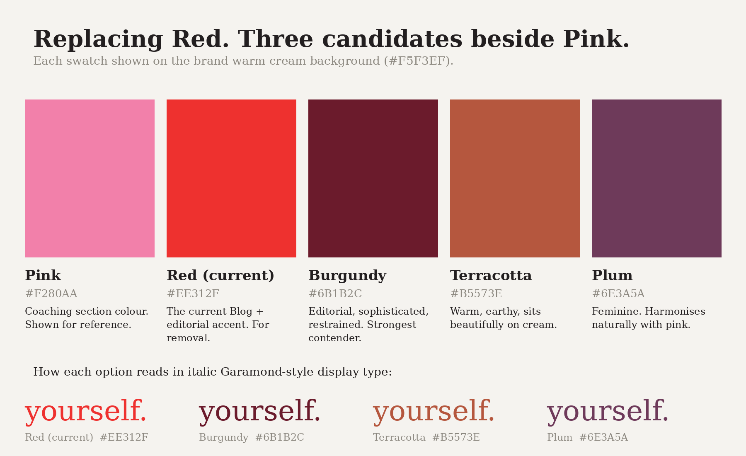
Candidate replacements for red, shown beside Pink on brand warm cream.
ACTION Do three hero mocks at the next iteration. One with Burgundy, one with Terracotta, one with Plum. Keep every other element identical so the only variable is the accent colour. This replaces Red everywhere across the site.

2.2 Reduce desktop vertical gaps
Mobile looks right. Desktop has too much vertical white space between sections, which breaks the magazine flow and makes the page feel padded rather than edited. Tighten the spacing on desktop only. Mobile stays as is.
Specific areas to compress on desktop:
- Below the hero block Come back to yourself before the Featured Reset Story.
- Between the rotating mantra strip and the Coaching section header Your inner world already knows.
- Between the Programmes tile grid and the Lifestyle section.
- Above and below the Workshops section.
- Between the Reset Letters card and the Anna Lou of London jewellery section.
- Between the client testimonials block and the As seen in press strip.
ACTION Audit every section to section transition on desktop. Cut section padding roughly in half where the gap reads as empty rather than as a pause. Cup of Jo is the benchmark. Warm, tight, edited.

2.3 Footer restructure
Current footer has every link in one band at the same weight. Mixed case, feels squashed, no hierarchy. Useful pages sit next to legal pages with no distinction. Rebuild in three tiers.
Tier 1. Primary navigation. Blog. Lifestyle. Workshops. Coaching. Shop. Media. Community. About. Sentence case. Set at the same size as the main nav. This is the band people use to navigate the site.
Tier 2. Social. Instagram. LinkedIn. Substack. YouTube. Podcast. On its own line below the primary nav, centred. Sentence case. Same size as primary, or one step smaller.
Tier 3. Legal and utility. Press. Contact. Privacy. Terms. Cookies. Set two sizes down from the primary nav. Sentence case. Muted grey, not black. This is where infrequent pages live and it should visually recede.
Tag line You don’t have to hold everything sits above Tier 1, centred, in Garamond italic. Join Reset Letters on Substack CTA sits below Tier 3, above the address line. Address and copyright line at the very bottom, small, muted grey.
Case consistency. Sentence case throughout the footer. No all caps. No mixed case in a single band.
ACTION Rebuild the footer in the three tier structure above. Use sentence case throughout. Primary nav at nav size, social one step smaller, legal two steps smaller in muted grey.

2.4 Logo size
The horizontal Anna Lou Wellness wordmark in the header is sitting too small. It reads as a caption rather than as a masthead. Scale it up so it has the presence of an editorial magazine title. Beautifully Whole stays centred below in Garamond italic, proportionally scaled.
ACTION Increase the header logo size. As a starting point, match the display weight of the hero H1 Come back to yourself. We can dial back from there if it reads too heavy on desktop.

3. Still open from the 21 April document
These items from round one need closing. Action alongside Section 2.

3.1 Press logos and certification badges still typed
Harrods, Selfridges, Harvey Nichols, QVC Japan, The Telegraph, Stylist, SheerLuxe are still rendering as typed text. Same for ICF Accredited, CPD Certified, TRE Provider. These must be licensed logo artwork and proper certification badges, not text in outlined boxes. Round one flagged this. Not actioned. Please action.
FIX Replace typed press names with licensed logo artwork. Replace typed certifications with proper badges where permitted.

3.2 Colour system across sections
I cannot fully verify the colour coded nav and section tinting from the preview in this environment. Please confirm the following points explicitly in the next iteration. If any are wrong, fix them.
- Blog. Currently Red, being replaced per Section 2.1. Once the replacement is chosen, every Blog nav accent, category label, date marker, and drop cap takes the new colour.
- Lifestyle. Gold or Cream #FFF0D2. Not mint. Mint is Shop.
- Workshops. Blue #7BAFDD. BOOK buttons. Pricing boxes. Browse All Workshops link. Not orange. Not gold.
- Coaching. Pink #F280AA. WORK WITH ANNA button. Pricing. Labels. Not blue.
- Shop. Green #5DCAA5. SHOP buttons. Product accents. Browse All Jewellery link.
- Media. Light gold #FFD07A. WATCH LISTEN READ labels. YOUTUBE PODCAST SUBSTACK tags. Not pink.
- Community. Warm cream #F5F3EF with black text. The Returning Circle button takes this colour. Not lavender.
CONFIRM Send a specific section by section screenshot confirming each of the above in the next iteration.

3.3 Em dashes and en dashes
House style has no dashes in written copy. Please do a final site wide sweep before sign off. Replace every em dash and en dash with a full stop, a comma, or rephrase. This applies to headings, body, cards, captions, and microcopy.
FIX Search the whole site for em dashes and en dashes. Remove all of them.

3.4 Crown a monogram on Reset Letters
Confirm the diamond a diamond decorative element and the small a monogram at the bottom of the Reset Letters card have both been removed. The crown monogram is not used on the web.
CONFIRM Send a zoomed screenshot of the Reset Letters card confirming removal.

3.5 Clinical SEO language in body copy
The two layer system is the rule. Clinical terms such as somatic coaching, nervous system, TRE, Flash EMDR, Brainspotting, IFS belong only in page titles, meta descriptions, and alt text. Visible body copy uses brand language. Inner world. Inner guidance system. Signal system. Signal scrambled. Signal back online. Please sweep the whole homepage and confirm.
CONFIRM Any remaining clinical terms in visible body copy must be replaced with brand language from Volume 3.

4. Content to verify against Volume 3
The round one document set the rule clearly. All body copy on every page must come from ALW_BLOG_Vol3_COMPLETE_FINAL_Sameer.docx. No paraphrasing. No placeholder copy. No invented articles. No fictional clients. No inferred text.
The following items on v5 appear to be invented or paraphrased. Each one needs checking against Volume 3. If the exact wording is not in Volume 3, replace it. Flag anything you are not sure about before writing anything.

4.1 The rotating mantra strip
The two quotes currently appearing on the rotating mantra strip are invented.
- “You don’t have to hold everything to hold yourself together.”
- “Your inner guidance system was never broken. It was waiting for you to stop overriding it.”
I have not yet recorded my mantras. They should go in as a CMS placeholder so I can populate them once the YouTube recordings are done.
FIX Replace both invented mantras with a CMS placeholder such as Mantra strip, pending Anna’s recordings. Do not invent mantras.

4.2 Article cards
The three article cards under the Featured Reset Story need verifying:
- The problem with being the strong one.
- What I wore every day this month, and why it matters.
- Living on Taggs Island. What the water teaches you about letting go.
CONFIRM Check each title and the associated body against Volume 3. If not in Volume 3, replace with real article titles from Volume 3.

4.3 Client testimonials
The three testimonials attributed to Claudine, Susan, and Nicky need confirming.
CONFIRM Confirm each testimonial and attribution against the testimonials I provided. Do not invent client stories.

4.4 Media section latest items
The YouTube, Podcast, and Substack card titles on the Watch Listen Read hub appear invented:
- Come Back to Yourself: practical tools for returning when you have drifted.
- Reset Letters: the conversation that started on Substack.
- The distinction between overwhelm and holding.
FIX Replace with CMS placeholder text. These should pull the latest real items from each channel once live, not invented titles.

4.5 Jewellery product cards
Three products currently on the Anna Lou of London section: Moonstone Necklace, Clear Quartz Necklace, Personalised Phrase Necklace. Please confirm these are the three pieces I want as the homepage anchor set and that the one line copy under each is from Volume 3, not paraphrased.
CONFIRM Verify product selection and copy against Volume 3 jewellery section.

4.6 Featured Reset Story body
The body copy on You are not overwhelmed. You are holding everything. starting “The distinction that changed how I work, how I move, and how I sleep” needs verifying against the Volume 3 version of the post.
CONFIRM Check every line is verbatim from Volume 3. Paraphrasing is not acceptable.

4.7 About block copy
Twenty five years leaves a trail. The paragraph covering Portobello Road, Drapers, Harrods, Selfridges, Harvey Nichols, QVC Japan. Please verify this is Volume 3 About copy and not paraphrased.
CONFIRM Check verbatim against Volume 3 About page.

5. Programme pricing to confirm
The pricing shown on the coaching tiles was not in my round one feedback document, and I do not remember signing these off. Please hold and let me reconfirm before the next build.
- The Reset. 6 weeks 1:1. Currently showing £1,500.
- Signal and Signal & Build. 12 weeks 1:1. Currently showing £3,000.
- The Reset Room. Monthly membership. Currently showing £25/month.
HOLD Do not publish these prices. I will confirm or correct them directly before the next version.

5.1 Signal and Signal & Build are two products, not one tile
At the moment Signal and Signal & Build appear on a single card. These are two distinct programmes. Signal is the 12 week 1:1 coaching programme. Signal & Build adds business strategy for founders and leaders. Please split them into two separate tiles so the distinction is visible.
FIX Two tiles, not one. Signal on its own. Signal & Build on its own, with the business strategy layer called out in the body.

5.2 Signal Method trademark symbol
Use The Signal Method™ with the trademark symbol consistently. In the Coaching intro paragraph it currently reads The Signal Method without the symbol. Add it.
FIX Every instance of The Signal Method on the site carries the ™ symbol.

6. Pre sign off checklist
Do not send another iteration until every item below is closed.
☐ Red replaced with the chosen candidate, mocked in all three options first (Burgundy, Terracotta, Plum).
☐ Desktop vertical gaps tightened across the sections listed in Section 2.2. Mobile untouched.
☐ Footer rebuilt in the three tier structure. Sentence case throughout. Primary, social, legal set at three distinct sizes.
☐ Header logo scaled up to masthead size. Beautifully Whole tagline scaled proportionally.
☐ Press names replaced with licensed logo artwork.
☐ Certifications replaced with proper badges where permitted.
☐ Colour coded nav verified per section with a screenshot confirming each of the seven colours in place.
☐ Every em dash and en dash removed from written copy, site wide.
☐ Crown a monogram and diamond a diamond decorative element removed from Reset Letters card.
☐ All invented body copy replaced with Volume 3 copy or CMS placeholder (mantras, articles, testimonials, media, jewellery copy, Featured story, About copy).
☐ Programme pricing on hold until Anna confirms.
☐ Signal and Signal & Build split into two tiles.
☐ The Signal Method™ symbol present on every instance.
☐ Clinical SEO terms absent from visible body copy. Brand language only.

Thanks Sameer. Big step forward this round.

